High-speed electrical tape fully automatic film wrapping cylinder production line
ZRP-4585+ZR1000+ZRB-500T+ZRNP-4522

Equipment Layout：
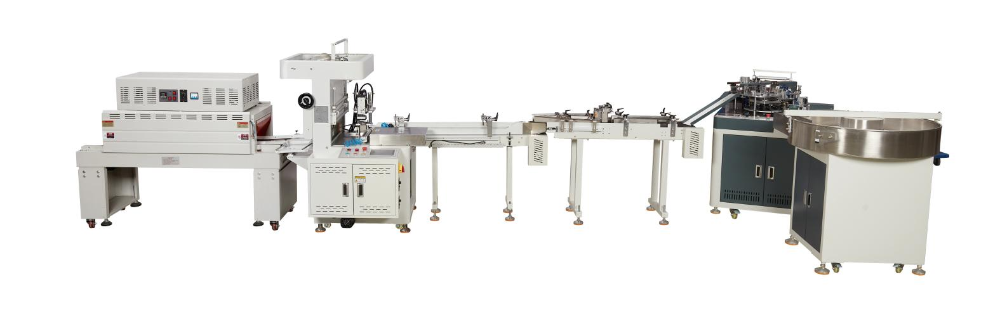
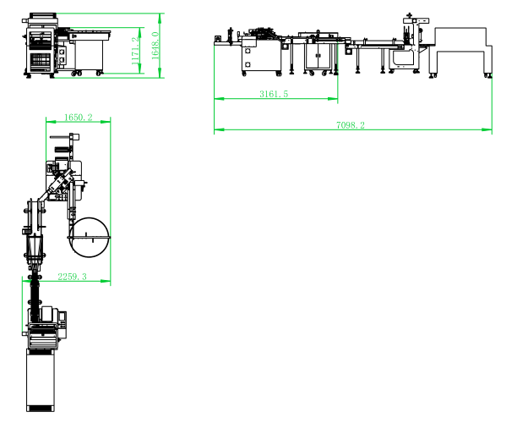
Basic Use：
It is mainly used for the whole production line of packaging single roll of electrical tape and 10 rolls of tape.

Equipment Advantages：
- Fuji servo control four-station turntable with precise transmission, which greatly improves the production speed.
- Color-pringting packaging film available （color length），also can packaging with labeling（transparent white film with set by servo）
- Suction label card, servo motor film, accurate film length.
- Stepper motor cutting film, quiet and high speed, perfect packaging, stable and efficient, 68-72 production capacity per minute.
- Photoelectric induction positioning material, color mark sensor detects color film.
- Tape label size adjustable
Automatic material feeding in two channels，able to package the tapes with marks at both sides with automatic packaging machine

lmpulse type cold-sealing cutter ensuring smooth edge free from per-heating,which is more convenient to use and emerging saving。Cutting edge of 500mm in effective width。

The patent design，Width and diameter adjustable through a hand wheel with thread，its adjusted to meet the different product whose width is different。
8,10 and 12 packaging methods settable via man-machine interface
- The whole process is high-speed, unmanned and automatic。

Main Technical Parameters：

Model | Fully Automatic High-Speed Electrical Tape Corner Folding Packaging Machine with Material Sorting System ZRP-4585+ZR1000 | Multi-Lane Sorting Type Tape Roll Packaging Machine  ZRB-500T | Air Jet Heat Shrink Tunnel Machine  ZRNP-4522
Power supply | AC200-240V  50/60HZ 3KW | AC200-240V  50/60HZ 0.6KW | AC380V  50/60HZ 12KW
Packing size | Ø（45-85）mm * H(10-25)mm | Ø（45-85）mm *H(10-20)mm | 450(W)*220(H)mm
Packing film | BOPP | PVC | PVC,BOPP,POF
Packing speed | 68-72/min | 10-15/min
Machine size | 1750(L)*1730(W)*1350(H)  1250(L)*1250(W)*1200(H) | 1260(L)*1250(W)*1520(H)  1880(L)*590(W)*1020(H)  1630(L)*320(W)*900(H) | 1200(L)*400(W)*200(H)
Net weight | 500kg | 350kg | 100kg

Configuration Parameters：

Model | Fully Automatic High-Speed Electrical Tape Corner Folding Packaging Machine with Material Sorting System SZP-4585+GL1000 | Multi-Lane Sorting Type Tape Roll Packaging Machine  STB-500T | Air Jet Heat Shrink Tunnel Machine  SBNP-4522
PLC  PLC Controller | Plc | CHSJL
touch screen | Mcgstpc | Mcgstpc
Air Circuit Breaker | chint | chint | chint
Switching Power Supply | Mingwei | Mingwei
AC Contactor | Schneider | Schneider
relay | OMRON | OMRON
Frequency Inverter | Coset
Push Button Switch | Koneda | Koneda | Koneda
Temperature Thermostat | Teshow |  | caoren
Magnetic Powder Clutch | YOSEEN
Stepper motor | Instar
servo motor | FUJI
servo motor | Jintian
reducer | Hasi Mai
Solenoid valve | STNC | STNC
Air Cylinder | CNTUOPU | CNTUOPU
Main Motor | sanly | sanly | Su Lin
Photoelectric sensor | Yangming | Yangming
Photoelectric switch | Daochuan | Daochuan
Linear Guideways | HIWIN
Tri-Color Warning Light | TʌYB
Bearing | NSK HRB | NSK HRB

